AWS- COST OPTIMIZATION

What is AWS Cost Optimization?
AWS cost optimization means reducing cloud spend while maintaining performance, security, and reliability. It follows the AWS Well-Architected Cost Optimization Pillar.
Core Principles of AWS Cost Optimization
- Pay only for what you use
- Right-size resources
- Use managed services
- Monitor continuously
- Use pricing models wisely
- Automate start/stop
- Use serverless where possible
- Design for elasticity
- Review frequently

Why Cost Optimization is Important
- AWS is pay-as-you-go → wrong setup = high bill
- Helps companies save money
- Avoids unused resources
- Makes cloud usage efficient

AWS Pricing Models
Model | Use Case
On-Demand | Short-term, unpredictable workloads
Reserved Instances (RI) | Steady workloads (1–3 years)
Savings Plans | Flexible long-term compute usage
Spot Instances | Fault-tolerant, batch jobs
Free Tier | Testing, learning
Pay-per-request | Serverless apps

- Common AWS Services That Increase Cost
  - EC2 instances
  - EBS volumes & snapshots
  - Load Balancers
  - RDS databases
  - Data transfer
  - CloudWatch log
Service-wise Cost Optimization
EC2
Techniques
- Right-size instances
- Use Spot instances
- Use Reserved Instances
- Auto Scaling
- Schedule start/stop
- Use Graviton (ARM)
- Use EBS gp3 instead of gp2
Example
- Problem: Running m5.2xlarge 24/7 for a low-traffic app
- Solution: Change to t3.medium + Auto Scaling
- Savings: Up to 70%
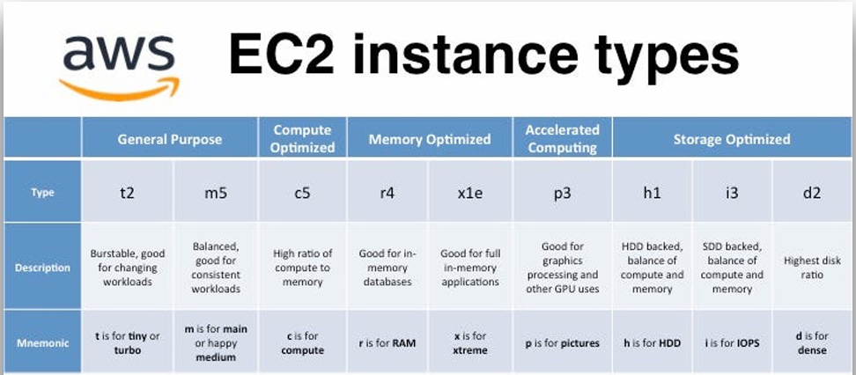
Example : change the instance type of instance after stopping instance —>action —> change instance type
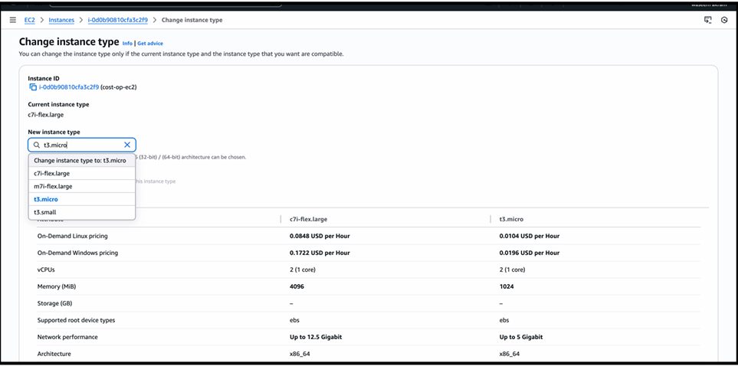
—> and save the changes this will optimise the cost of instance
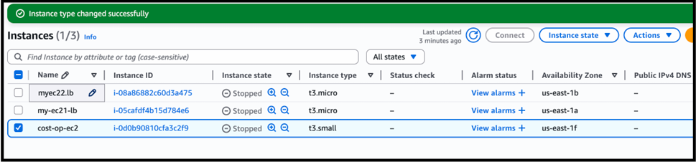

Result:
- Same application works
- Less cost
- Better resource utilization
—> “Right-sizing EC2 means selecting the correct instance size so we don’t pay extra for unused CPU and memory.”

S3- Simple Storage Service
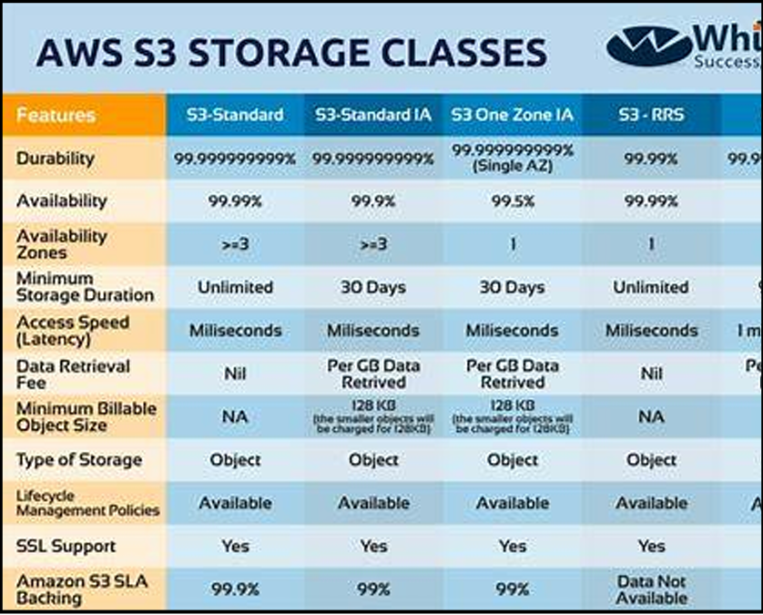
Storage Classes
Class | Use
S3 Standard | Frequently accessed
S3 IA | Infrequent access
S3 One Zone IA | Non-critical
Glacier | Archival
Deep Archive | Long-term backup

Techniques
- Lifecycle policies
- Intelligent-Tiering
- Compression
- Delete old versions

- Cost Optimization Action Performed on S3
Action: Changed storage class of object to cheaper option
Points:
- Initially, the object was stored in S3 Standard
- S3 Standard is used for frequently accessed data

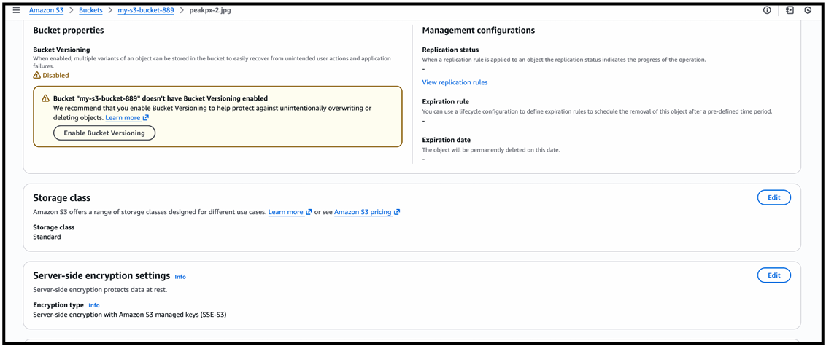

- The file was not accessed regularly
- Keeping it in S3 Standard was unnecessarily increasing cost
- To reduce cost, the storage class was changed to Glacier Deep Archive

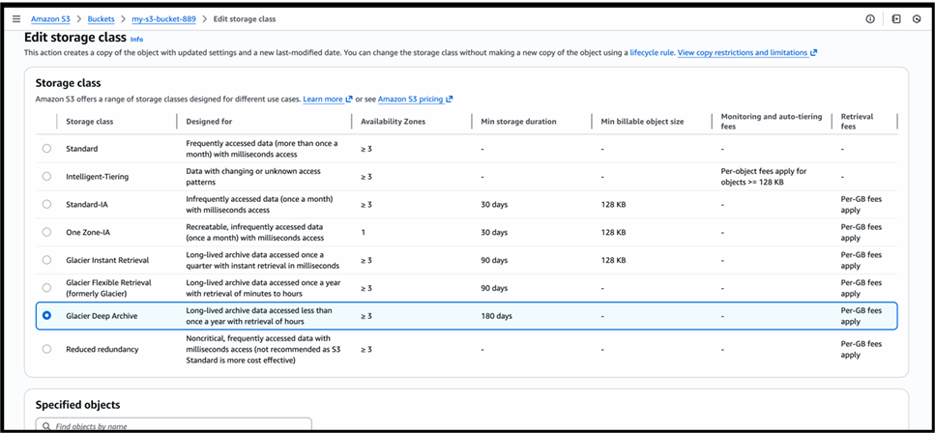

Glacier Deep Archive is used for:
- Long-term storage
- Rarely accessed data

After changing the storage class:
- Storage cost was significantly reduced
- Data is still safely stored
- Only retrieval time is higher, which is acceptable for archive data
Result:
• No data loss
• Lower S3 monthly bill
• Effective cost optimization achieved
- “We optimized S3 cost by moving rarely accessed data from S3 Standard to Glacier Deep Archive, which reduced storage cost.”

- Enable Lifecycle Policies (S3 Cost Optimization)
Action: Cost Optimization Action Performed: Enabled Lifecycle Policy
Points:
- Data stored in S3 keeps increasing over time
- Old files are not accessed frequently
- Keeping old data in S3 Standard increases cost
- To optimize cost, an S3 Lifecycle Policy was enabled
- Lifecycle policy automatically manages storage class based on age
- No manual work is required after configuration
Example:
- Objects stored in S3 Standard
- Lifecycle rule configured:
- After 30 days → move data to Glacier
Result:
- Storage automatically moved to cheaper class
- No data loss
- Reduced S3 storage cost
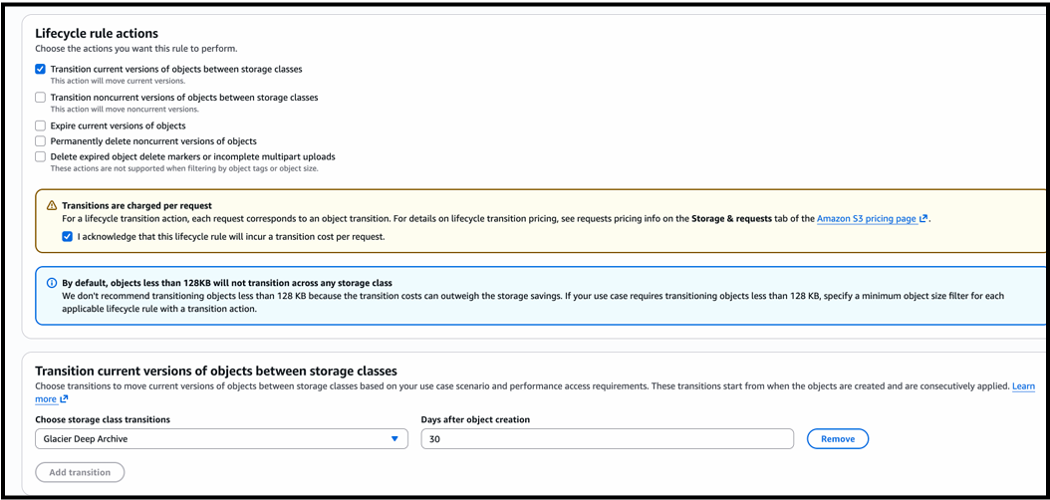

S3 Lifecycle Policy – Cost Optimization (Current Versions)
Points:
- Newly uploaded objects are stored in S3 Standard for immediate access
- After some time, these objects are rarely accessed
- Keeping such data in S3 Standard increases storage cost
- A lifecycle policy was configured to manage this automatically
- The rule transitions current versions of objects to Glacier Deep Archive Transition happens 30 days after object creation
- Glacier Deep Archive is the lowest-cost S3 storage class
- This significantly reduces storage cost for long-term data
- No manual intervention is required after configuration

Result:
- Automatic movement of old data to cheaper storage
- Reduced S3 monthly bill
- Efficient long-term data storage

RDS / Aurora
Techniques
- Right-size DB instance
- Stop RDS when not in use
- Use Aurora Serverless
- Storage auto-scaling
- Reserved Instances
- Multi-AZ only if required
Example
Dev DB running 24/7 → schedule stop at night
60% savings
Load Balancer
Type | Cost
ALB | Moderate
NLB | Cheaper for high throughput
CLB | Legacy

Note: Use ALB only if you need L7 features
CloudWatch
Techniques
- Reduce log retention
- Delete unused alarms
- Use metric filters
- Export logs to S3

NAT Gateway
Problem
Very expensive for traffic
Solutions
- Use VPC endpoints
- Use NAT instance for low traffic
- Reduce cross-AZ traffic

Real-World Cost Optimization Scenarios

Scenario 1: Dev/Test Environment
Problem
Running 24/7
Solution
- Auto stop/start
- Smaller instance
- Use Spot
Savings
Up to 70%

Scenario 2: Log Storage Explosion
Problem
TBs of logs in S3 Standard
Solution
Lifecycle:
- 30 days → IA
- 90 days → Glacier
- 365 days → Delete

Scenario 4: Overprovisioned Databases
Problem
db.r5.2xlarge but low utilization
Solution
- Right-size
- Reserved Instance
- Aurora Serverless

Cost Optimization Checklist
✅ Right-sizing
✅ Auto Scaling
✅ Spot Instances
✅ Reserved Instances
✅ Lifecycle policies
✅ Auto stop/start
✅ Monitoring
✅ Alerts
✅ Tagging
✅ Delete unused resources

Interview Question Examples

- How do you reduce EC2 cost?
- Right-sizing
- Spot
- RIs
- Auto Scaling
- Scheduling

- How to optimize S3 cost?
- Lifecycle rules
- Intelligent tiering
- Compression
- Version cleanup

- How to reduce NAT Gateway cost?
- VPC endpoints
- NAT instance
- Reduce traffic

Conclusion:
AWS Cost Optimization helps organizations reduce cloud cost without affecting performance. By choosing the right service size, removing unused resources, and monitoring usage, we can save a lot of money in AWS

